www.nc-ape.com
Jolanda Hengstman, CAPE, NBCT
Adapted Physical Education Consulting Teacher
Charlotte-Mecklenburg Schools
Jolanda.hengstman@cms.k12.nc.us

Object control skill: CATCHING
Purpose of the skill: gain control of the tossible using hand(s) when it is thrown or bounced.
Catching happens in response to a throwing, tossing, rolling or bouncing action. The catcher needs to be ready to adjust to gain control of the object using eye-hand coordination.
This is a difficult skill and depends on the skill level of the person throwing/tossing the ball.
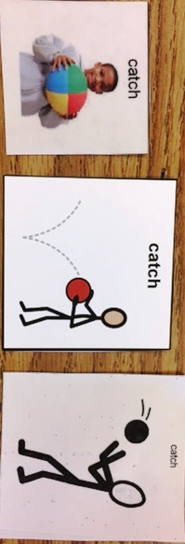
Fun adaptations:
  - Shorten the distance to increase engagement.
  - Make it interesting, use a fun object to toss with, use an object that makes sound when tossed, or hold a receptacle to catch the object in.
  - Start with self-bounce-catch and move up to bounce-pass by a peer buddy.
  - Start with self-toss-catch and move up to catching a tossed ball by a peer buddy. Self-toss can be done with a ball on a string looped around the wrist.
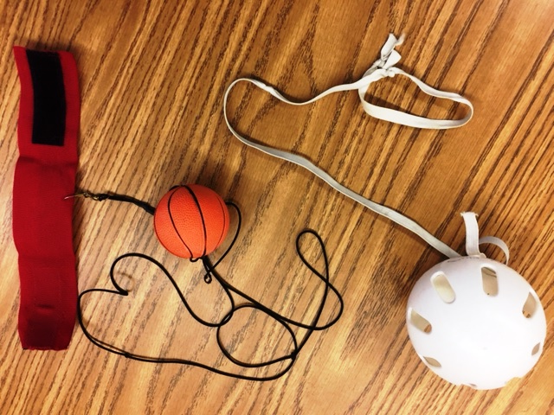
Balls on string, homemade version, and commercial version with Velcro wrist loop.

  - Count how many good catches. Use a counting-board to visualize expectation and achievement.
  - Limit verbal instructions to cue words: hands out, grasp, catch, and the like.
  - No wait time, engage the student.
  - Use tossibles that don’t roll away such as spider ball, sock-ball, beanbag, or crumpled piece of newspaper in a small plastic bag.
  - Suspend the ball. Student catches the ball when it swings towards them.

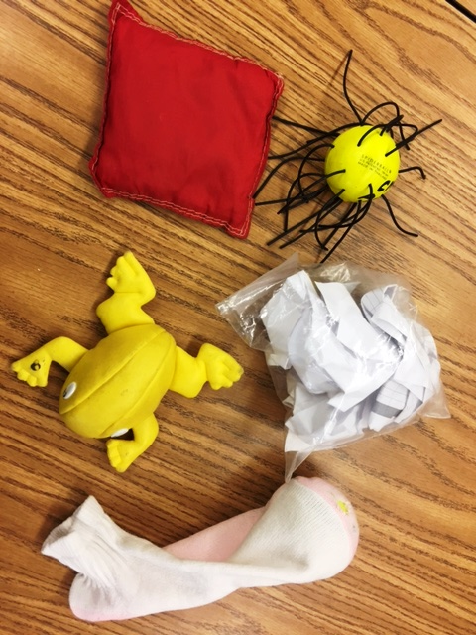

Tossibles that don’t roll away: beanbag, spider ball, crumpled paper in plastic bag, frog, sock-ball.

Strategies for lack of technique:
- Use a larger ball.
- Use a slightly softer ball that can be squeezed such as a foam ball or peanut-ball. Make a ball softer by letting some air out.
- Use a ball with openings such as O-ball or Geo-ball. This is easier to catch than a smooth ball.
- There are balls with a “sticky” surface.
- Allow trapping if catching using hands only is too difficult. Focus on being successful controlling the ball.
- Use peer buddies who can toss or bounce-pass a ball directly into the hands of another student.
- Remove the armrests of a wheelchair to create more room to move the arms.
- Have students who use crutches or a walker sit down to free their hands to practice catching.

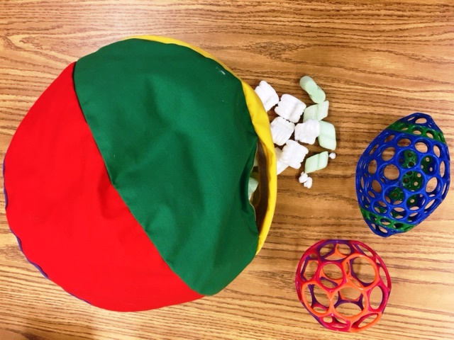

O-ball or Geo-ball, homemade cloth peanut ball. These can also easily be suspended.
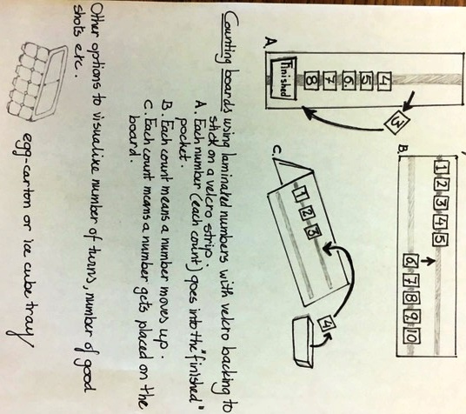
Counting good catches or turns can be very motivating. Using counting boards makes expectations visible.

