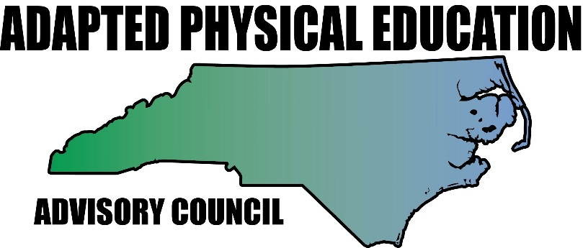
www.nc-ape.com

Lara Brickhouse, MAEd., Certified Adapted Physical Educator, Durham, NC
Lara.Brickhouse@dpsnc.net

Get Outside! – It’s Easier Than You Think part 1
Try Disc Golf.

Grades: k – 12

It’s time for a little fresh air and sunshine.
Appeal to all the senses
Address the needs of all learners
Incorporate other curricular areas
Your gym is being used
Its fun

Frisbee (“Disc”) Golf

Equipment (adaptations):
You don’t have to have the chain link baskets or the newest, most expensive mid-range disc to play. With a little creativity, you can set up a course using equipment you already have. Frisbee Golf, just like Tiny White Ball Golf, is a lifetime sport!
- Targets or “Holes”
  - If a Frisbee can fit in it, use it!
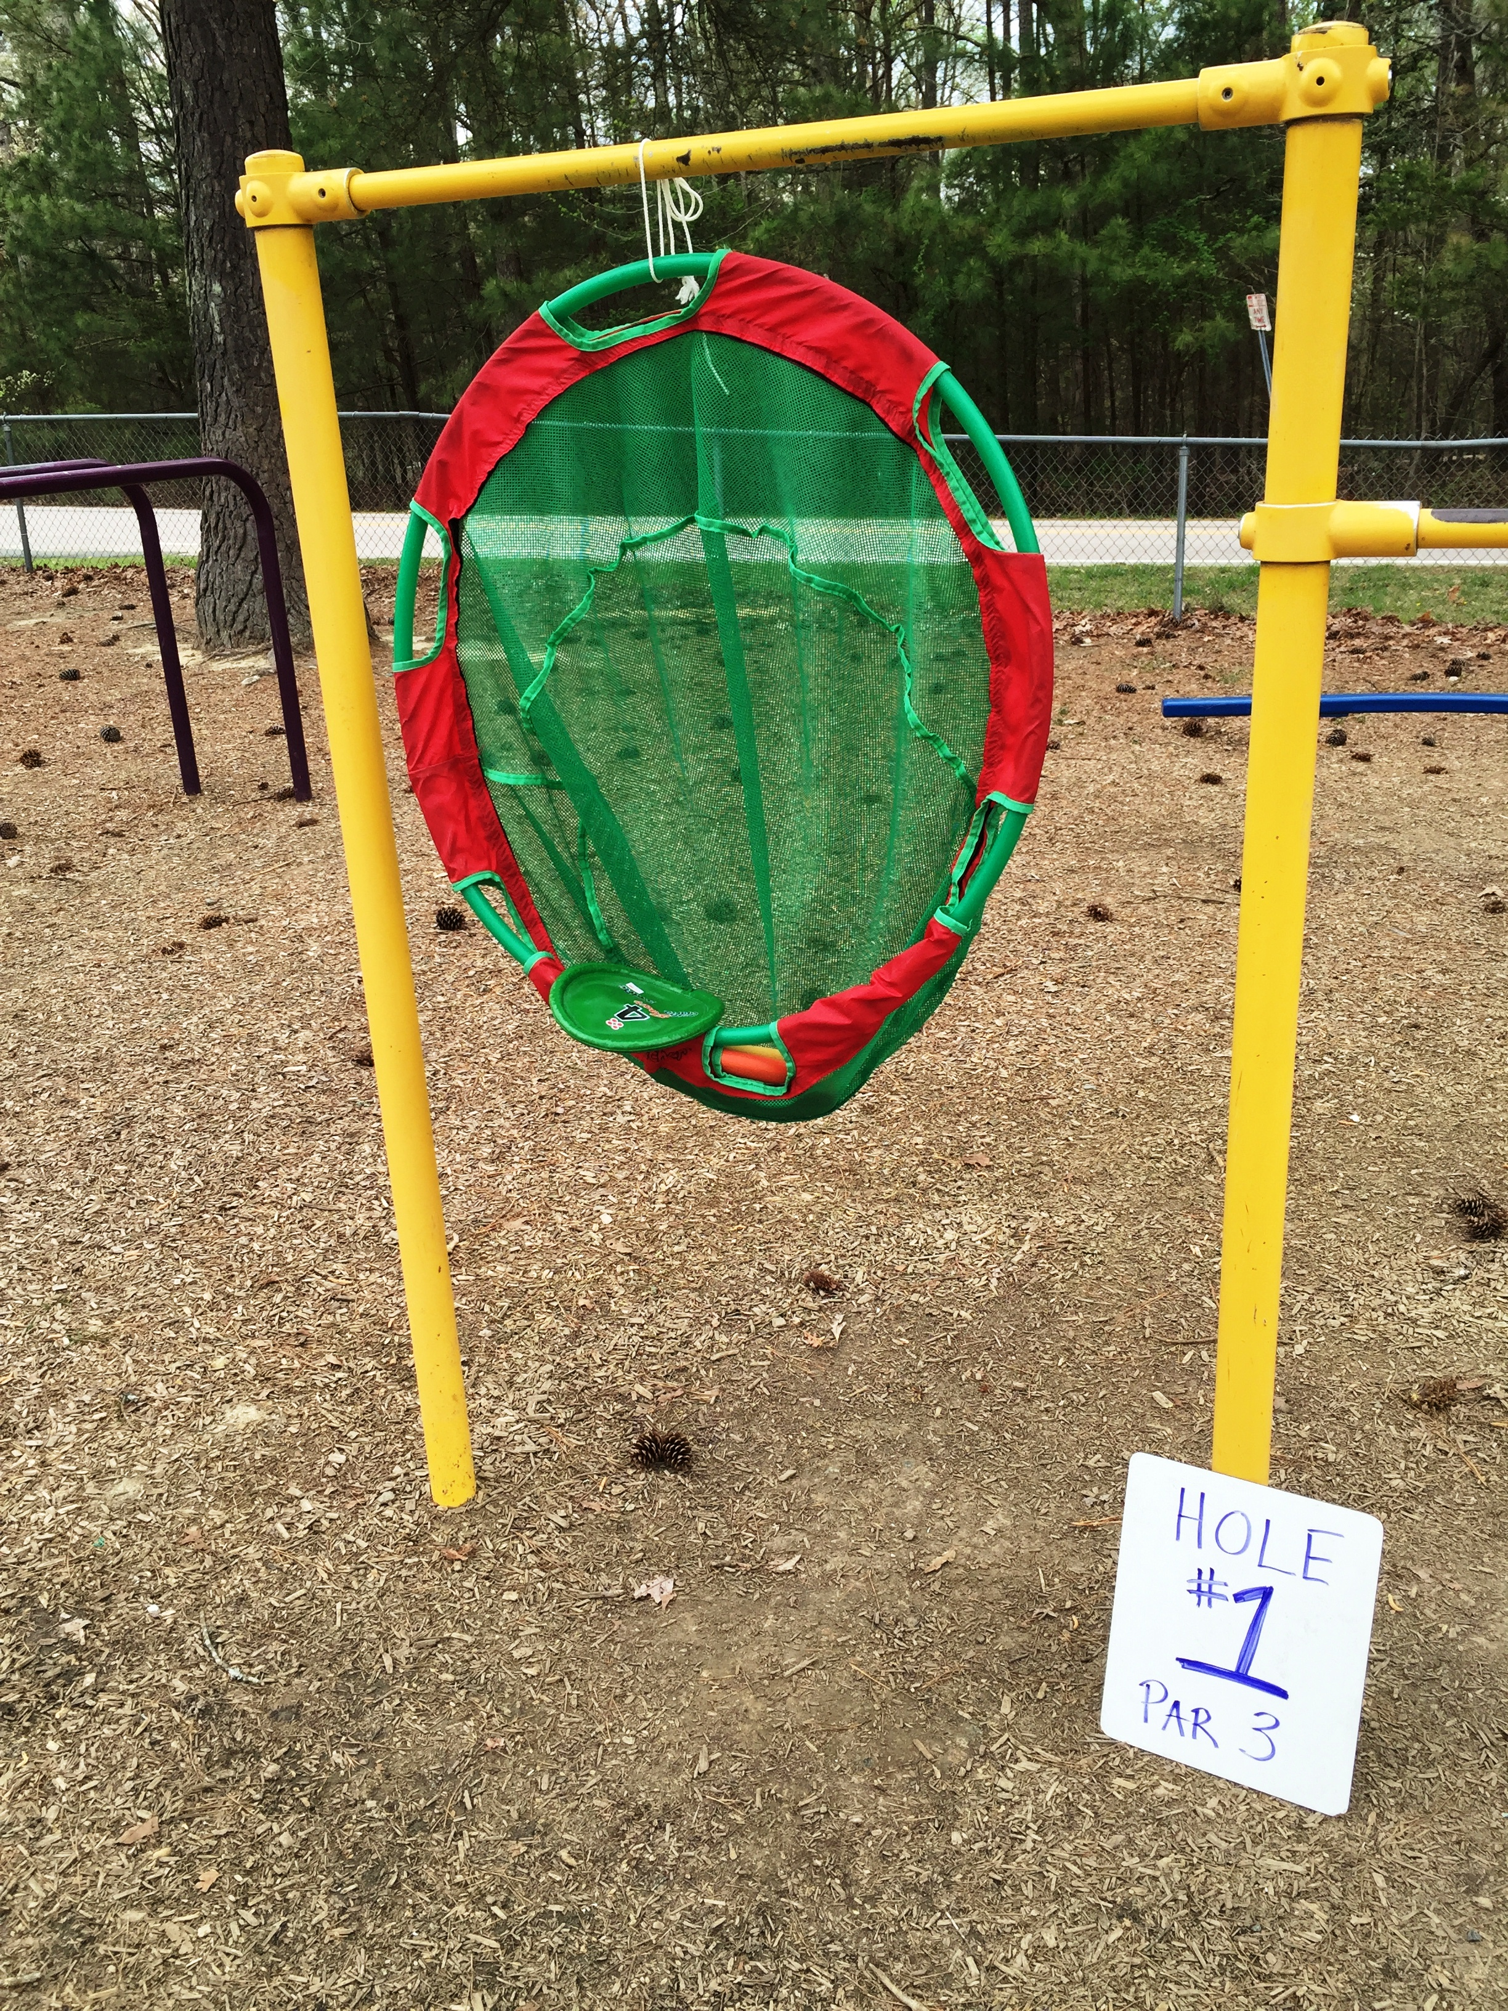
    - Buckets
    - Small laundry baskets
    - Crates
    - Cardboard boxes
    - Hula Hoops
      - Attach a net to your hula hoops for easy retrieval
  - Appeal to the senses:
    - Attach scarves, streamers, bells, chimes, and other stimulating items to the targets
    - Place targets in various locations and at various levels. Make sure your locations are accessible to all students:
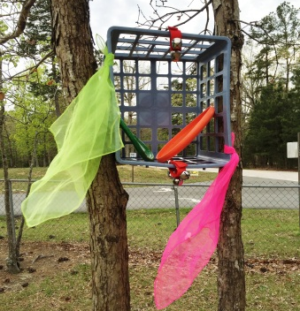
      - In the grass beside the oak tree,
      - Suspended 2-3 feet in the air from a light post,
      - Hanging between swings on the swing set,
      - Leaning against the building on the opposite side of the ditch,
      - Behind the flag pole, to the right of the small rain puddle or “water hazard.”
    - Get creative! Chances are you’ll have as much fun setting up the course as they will playing it!
- Frisbees or “Discs”
  - Teach students about the different discs used (driver, mid-range, putter), but use the Frisbees you already have.
  - Allow students to put an identifying mark on their Frisbee to avoid mix up.
    - A tiny piece of tape with initials will do the trick, and can be easily removed.
  - Use Frisbees that light up or make noise for students with sensory integration needs, and because they’re COOL!

- Challenge Your Students – Take advantage of the fact that Disc Golf may be unfamiliar to some students, and design lessons that incorporate other subjects and encourage personal growth.
- Math: adding the score.
- Problem solving: find a way around the “hazard” or a way to include everyone.
- Map reading or designing.
- Time management and turn taking.
- Leadership when playing as a team.
- Design of the course: get student input.
Integrating other subjects is a great opportunity for students with special needs to demonstrate various skills their peers may not know they have.
    - Sammy may not be able to grasp and throw a Frisbee, but she can read a map and knows how to use a compass! Can her 4th grade classmates do the same?

Safety Considerations

A few tips and reminders when taking students outside for class:
- Take a walkie-talkie or another reliable form of communication.
- Double check student files for listed allergies, and treatment plan.
- If a student is prescribed an EpiPen, don’t forget the EpiPen!
- Be mindful of uncomfortably high or low temperatures.
- Limit the amount of exposure to direct sunlight. A hat may be needed.
- Allow frequent water breaks or rest breaks.
- Explore areas beforehand to ensure proper accessibility.

