www.nc-ape.com

Kelly Givens
Adapted Physical Education Specialist Gaston County NC
kdgivens@gaston.k12.nc.us

Modified Volleyball

Spring is here and summer is around the corner...time to bring out the balloons and beach balls!
Volleyball activities are fun for all ages and ability levels, and limited only by your imagination.

Skills: catching, throwing, striking, tracking, turn taking, balance

Modifications:
Equipment: Net (rope on the floor or between cones, mats on their side, any barrier to see over
or through), vary the height of the “net”.
Ball (balloon, beach ball, volleyball trainer)
Court (small, large, no boundaries)
Grouping: individual, with a partner, small group, large group
Rules: allow catching, multiple taps, bounce
Positioning: seated on the floor, on a scooter board, or on an exercise ball
standing independently or using a walker

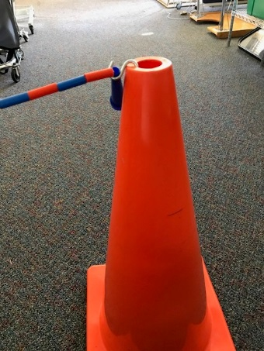

Apply the principal of universal design. This means that all students have access to any of the adaptations offered. Allow all students to make choices how they like to practice and play. When having success, when learning a new skill to be proud of, and having fun, all students are more likely to stay engaged.

How we play:

Various activities to play across a “net”:
- Very low net-
  - Students standing tap ball or catch/throw ball across the net to a partner, allowing ball to bounce then return ball to partner
- Very low net-
  - Students seated on floor, chair or exercise ball partners catch and throw or strike a beach ball over the net
- Medium to high net-
  - Students seated on a therapy ball or standing (or position based on student needs)
  - suspend beach ball, punch ball with small items inside for sound, or a balloon from the net for partners to practice tapping, striking or to catch/throw

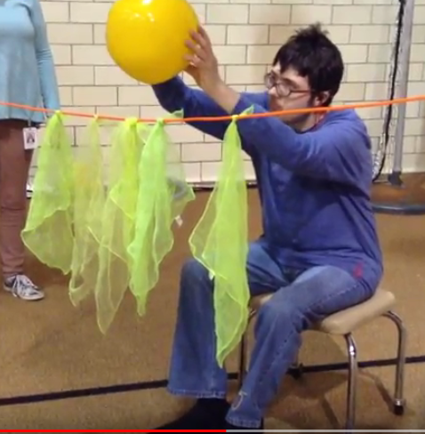

- Medium to high net-
  - Use Velcro cable tie, binder clip, binder ring or even a carabineer to gather net and attach a hula hoop.
  - Students seated on the floor, a therapy ball or standing (or position based on student needs)
  - Students tap/throw a beach ball or balloon through hoop. The ball or balloon can also be suspended from the hoop.

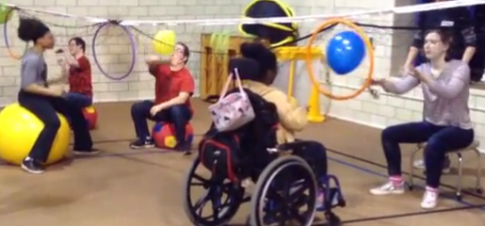

Pointers:
- Ask students with a visual impairment what they can see (offer bright colors and larger balls) and when they can see it (from what distance, from the side or up high).
- Placing peer buddies on a scooter or a chair levels the playing field
- Counting taps in a row (keeping the ball of the floor) is very motivating. This can be done individually, with a partner or a small group.
- Small group games 2 vs 2 create fun situations that are less predictable, meaning our students learn to adjust
- Small group games 2 vs 2 or 3 vs 3 create great opportunities for unified (inclusion) games. Everyone has to catch/touch the ball before it can go over the net.

Seated or sitting volleyball is a Paralympic sport ( https://www.paralympic.org/sitting-volleyball) and is a fun activity for students of all ability levels.

