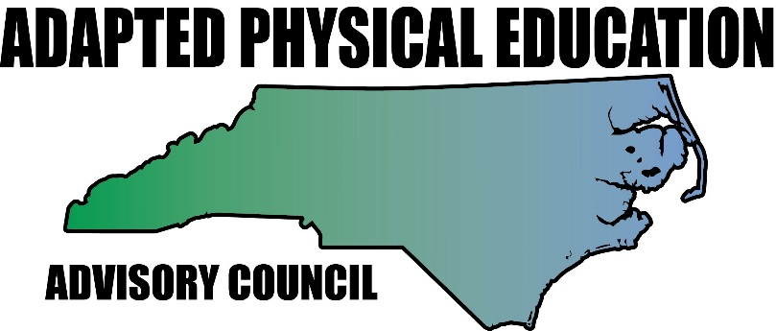
www.nc-ape.com

Amy Clark, Adapted Physical Education Teacher, Charlotte, NC
Amye.clark@cms.k12.nc.us

Get your students on wheels! Think outside the box. Combine it with literacy!

Grades: k – 12

It’s time to get off your feet and onto some wheels-Let’s GO!
- Address the needs of all learners
- Incorporate other curricular areas
- Learn a new life skill
- It’s fun!

Oh the places you’ll go!

You can incorporate Dr. Seuss books on travel and create an obstacle course for your students to travel utilizing different types of wheels (roller skates/blades, all types of scooters and bicycles/trikes) while learning different road signs and rules of the road. You can also work on concepts such as: over, under, around, and through or directions in space: left, right, forward, sideways and backwards. Students in wheelchairs can don a pair of skates to get the feel of them or use a scooter board/chair.

Equipment (and modifications):

- Dr. Seuss books:
- Oh the places you’ll go!
- Go Dog GO!
- Marvin K. Mooney will you please go NOW?
- Assorted scooters (chair scooters, board scooters, Razor scooters), bicycles, trikes, tricycles, roller skates and roller blades.
- Low pile carpet to line the course: this slows down the rolling for those on skates making them more successful.
- Helmets
- Poly road signs, directional signs or make your own!
- Augmentative devices: switches to record the names of road signs.

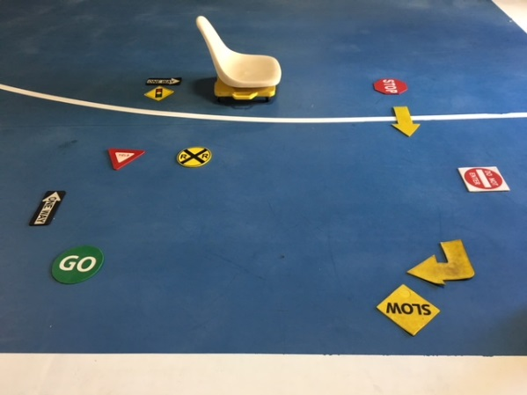
Traveling the road course:

- Lay out the carpet strips as the “roads” around your course.
- Set up directional signs and road signs around the course to direct students. Depending on your floor surface you can use arrow shaped floor markers, poly spots or floor tape. They do make poly road signs too if your budget allows or submit a Donor’s Choose Grant Proposal!
- Velcro an augmentative communication device, more commonly known as a “switch”, to the signs, and record the name of sign. At each sign, students with disabilities can press to activate the switch and listen to the name of the sign they are at.
- Read one of Dr. Seuss’s books before sending the students out on the course. Connect certain vocabulary to the way they move, directions, and signs.
- Assist students with their equipment and helmets.
- Make sure each student gets an opportunity to try different “wheels”.
- Challenge your students to move through the course like the characters in the book or in a new way.

Safety Considerations

A few tips and reminders when placing students on wheels for class:
- Students need to wear a helmet when on a skates, trike, and bike or stand up scooter (Razor).
- Make sure that students have a stand by assist when first trying out skates or learning to ride a bike until you know they have their balance.
- Proper hand placement on the scooters is a MUST!

