Simple games can teach many valuable lessons otherwise known as Functional Lifetime Skills while providing moderate to vigorous physical activity and teaching academic (health) concepts . This game covers the following lessons:
- Waiting and Taking Turns
- Following Specific Start Cues
- Directionality
- Moving Safely in General Space
- Observing and Respecting Set Boundaries
- Following Game Rules
- Creating a Healthy Meal

Barbara Meleney, NBCT/CAPE
Durham, NC

Fun with Food: “Around the Block” Game
*Awesome Video for Introduction to Lesson: Choose My Plate: A Lyrical Rendition on youtube.com was created by Duke University Nursing Students.

Activity Overview: Combines low-organized game concepts and nutrition concepts. Teams race “Around the Block” before collecting pieces of play food to create a healthy meal. Each member of the team creates their own version of a healthy meal by choosing food from each of the 5 food groups and matching the food to the appropriate place/color on their “My Plate” placemat.
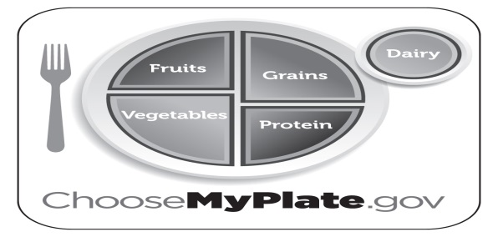
*Find this free printable placemat visual on www.choosemyplate.gov.

Equipment: Enough 3-D Plastic Play Food and empty school milk and juice cartons (works well for students with disabilities) and/or Food Picture Cards for each student to have one piece/picture from each of the 5 food groups (example: 24 students would need 24 pieces or pictures of fruit, vegetables, grains, protein, and dairy. 1 “My Plate” Placemat for each player. 6-8 team markers/cones depending on class size. Number Cards 1-4

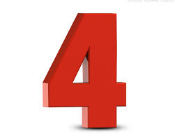
ONE TWO THREE FOUR
Set Up: Divide class in teams of 4 max (limit wait time). Each team stands next to a cone facing the center of the gym with a My Plate Placemat on the floor in front of each player. Each team member is assigned a number (1, 2, 3 or 4). All of the food and/or food cards are placed in the center of the gym. When a player’s number is flashed (use visual) and called, the student assigned that number runs 1 lap around the black line, moving behind the other teams. When the player returns to his team, he runs to the center of the gym and retrieves one piece of food, brings it back to his “My Plate” Placemat and places it in the correct space on his plate. Game continues until all players have retrieved 5 food items and have completed their plate.

Food

Variations/Recommendations:
*You can find images of food on Google Images or in newspaper grocery store circulars.
*Part to Whole: If necessary practice playing parts of the game separately before playing full game. (Running a lap when number is called, selecting one food item at a time, etc.).
*Change the mode of travel when moving around the gym.
*For more advanced or older students: Discuss the recommended numbers of servings for each food group per day. Have players retrieve 2 pieces of food on each turn and toss them into a team pile. At the end of the game have each team create one day’s worth of meals demonstrating the recommended servings of each food group per day.

Check out the video of students with multiple disabilities receiving differentiated instruction during a simple food relay game at the North Carolina Adapted Physical Education Advisory Council website: www.nc-ape.com

