www.nc-ape.com
Teresa Hudson, NC-APE-Advisory Council Contributor
Buncombe County NC
Sensory Obstacle Course
This is a Great idea for:
- Students using wheelchairs and/or mobility issues
- Students needing sensory stimulation
- Students who are easily distracted, this will get their attention!
- All students.
There are many different ways to set up an obstacle course which is also true of the sensory course. Be creative and use the equipment you have, apply a little elbow grease and be creative.
Here are a number of ideas that worked well for me, hope you and your students enjoy them as well.
- PVC structure (dimensions ………) made from …. Diameter PVC pipe and corner pieces to suspend items from such as
- Swim noodles with a bell tied to the end of each noodle (see picture).
- Balloons with jingle bells inside.
- Beach balls.
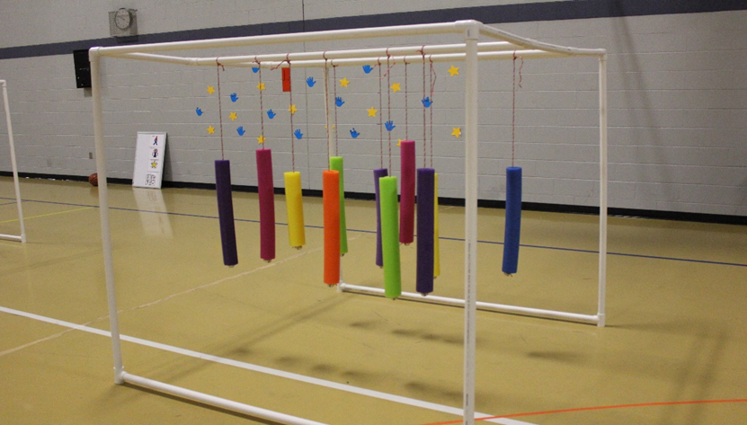
- A piece of lattice provides students who use wheelchairs that bouncing effect of riding over a rough road that many love. Other students can use scooters or it can be just a “different” type of surface to walk over. I also used an extra wheelchair to give all the students the experience, if they were interested.
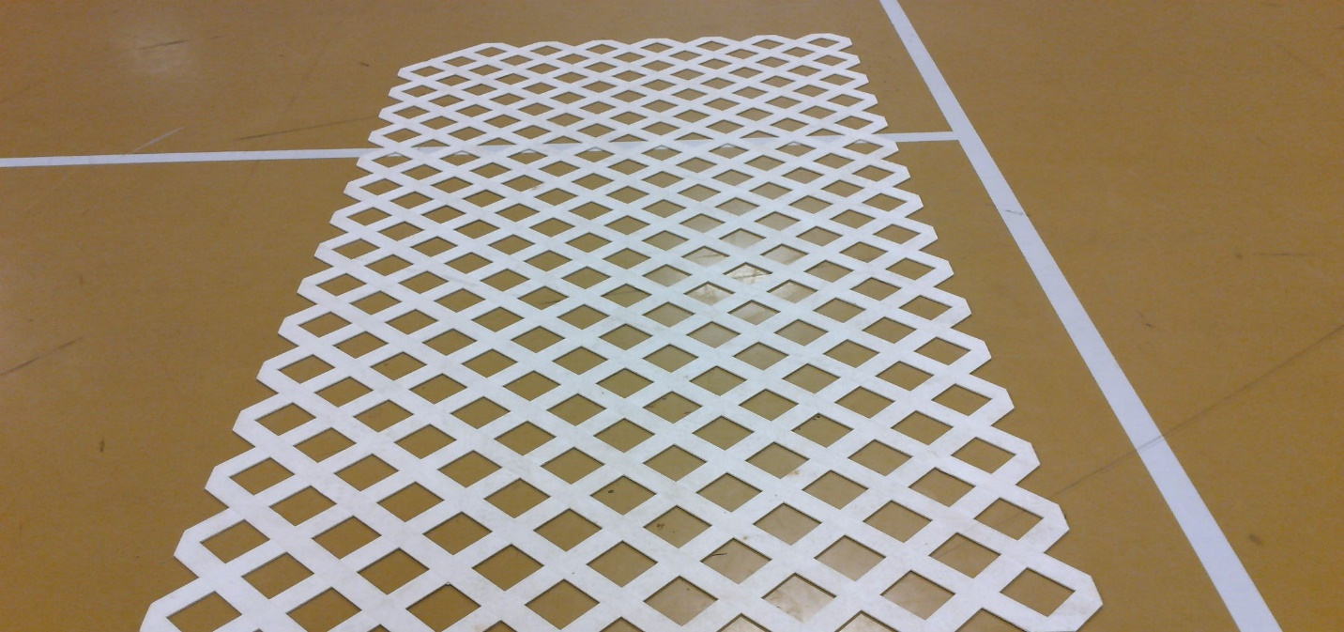

- Bubble wrap is great fun! The big bubble wrap is the loudest and works better for students that may walk through the course but the smaller bubble wrap will work.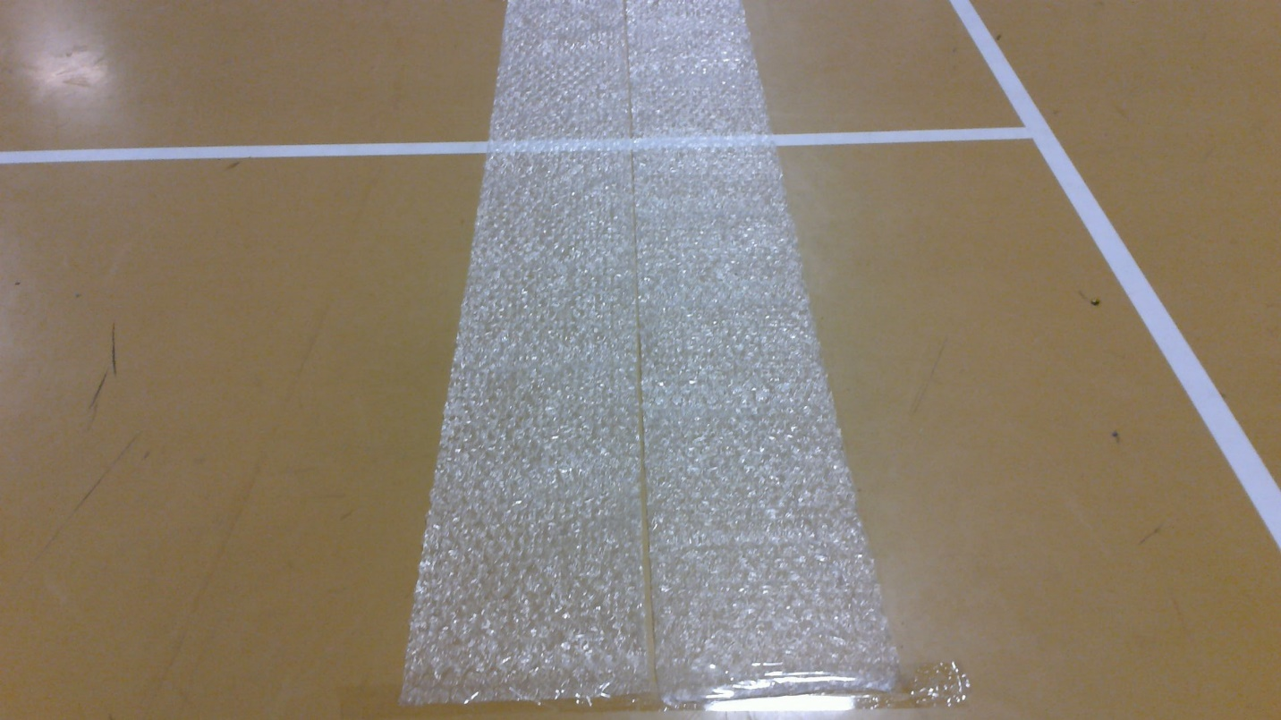

- A favorite!! The PVC structure (or two put together) and covered with a sheet of black plastic, create a tunnel to walk or wheel through. Add: Lights.
Items to brush up against.
Eyes on the outside to give it some personality.

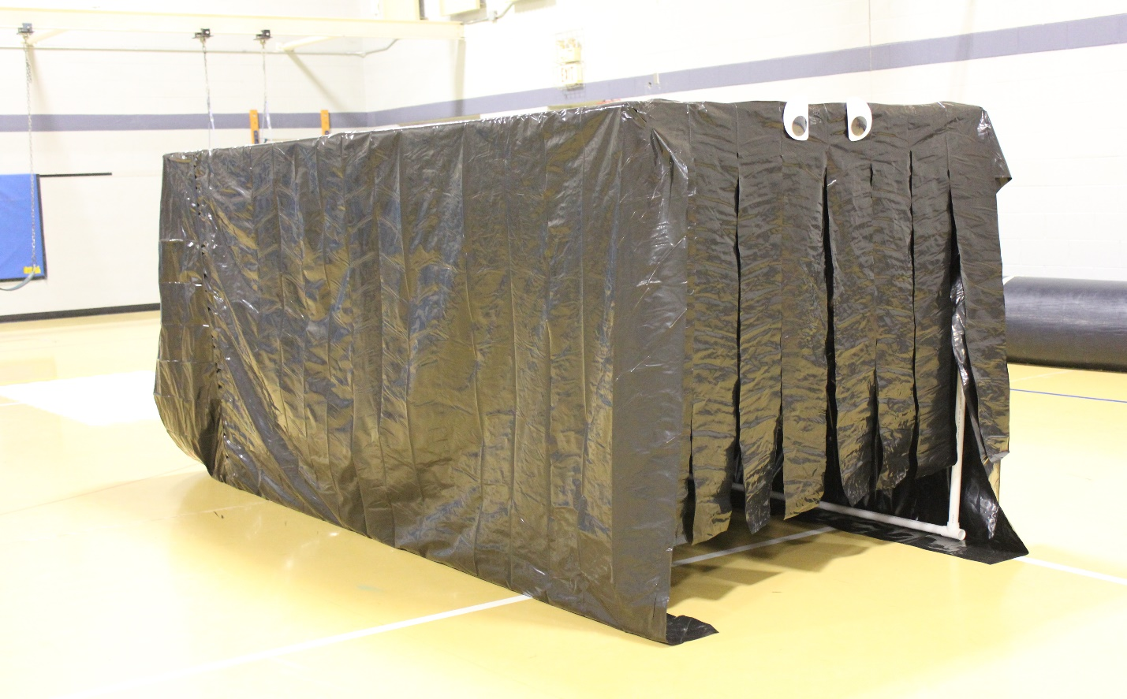

- Plastic strips called gym slates, or rulers provide the feeling of riding over a railroad track.
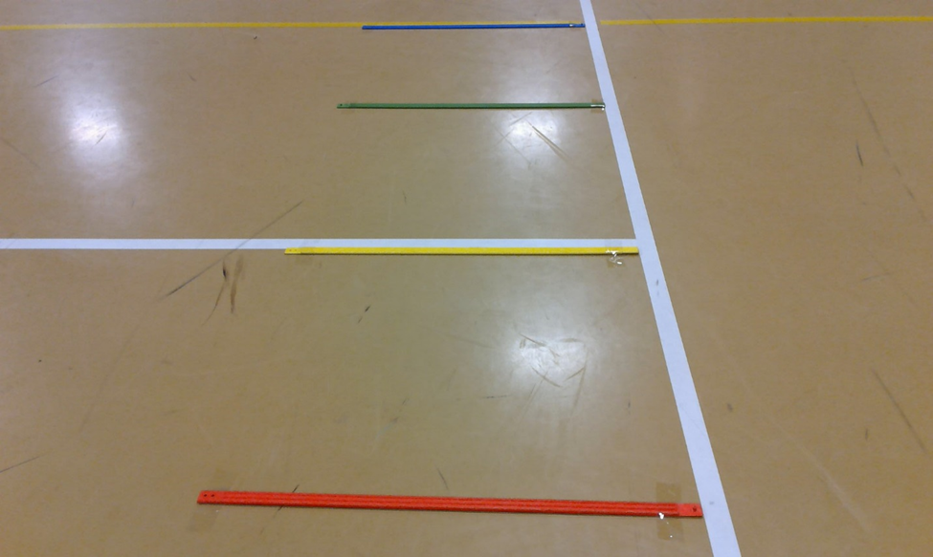

- A different structure to suspend items from:
An archway created with three- five foot pieces of PVC connected with two tees (or elbows). Two large cones are used for the bases.
Add: scarves
Srips of crepe paper
Fan !!!! to blow on the students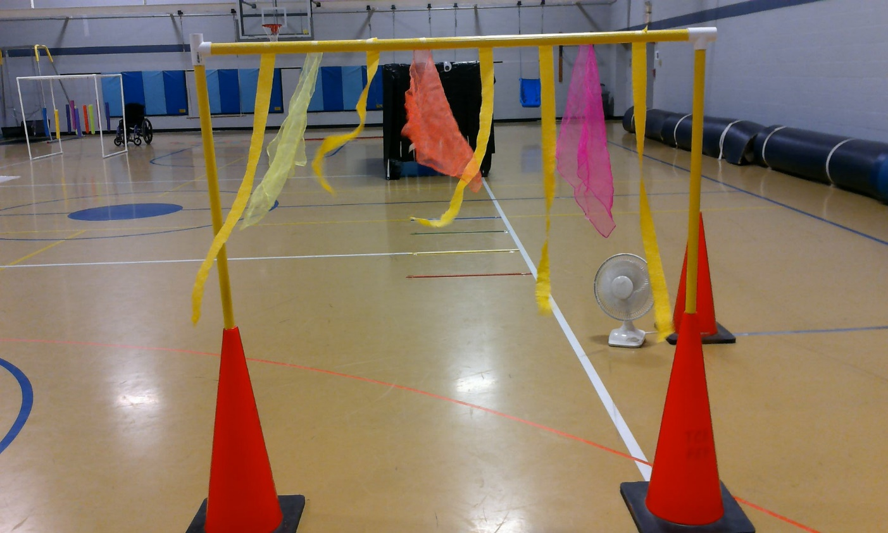

These are some of the ideas I have come up with so far. I come across new ideas for things to try on a regular basis. Adding a new structure or obstacle is a process of trial and error, so don’t give up if something new doesn’t work the first time! Please share any ideas you come up with- it is always nice to try something new! Think outside the box!

