www.nc-ape.com

Lara Brickhouse, MAEd., Certified Adapted Physical Educator, Durham, NC
Lara.Brickhouse@dpsnc.net

Get Outside! – It’s Easier Than You Think part 2
Try Kickball

Grades: k – 12

It’s time for a little fresh air and sunshine.
Appeal to all the senses
Address the needs of all learners
Incorporate other curricular areas
Your gym is being used
Its fun

Kickball

Yes, kickball can be played inside, but it’s much better outside! Baseball and softball fields can double as a kickball field, and if not just grab your cones and find some open space! Utilize these suggestions and modifications for base running and defense to increase time-on-task and decrease frustration!

Equipment (and modifications):
- Base running:
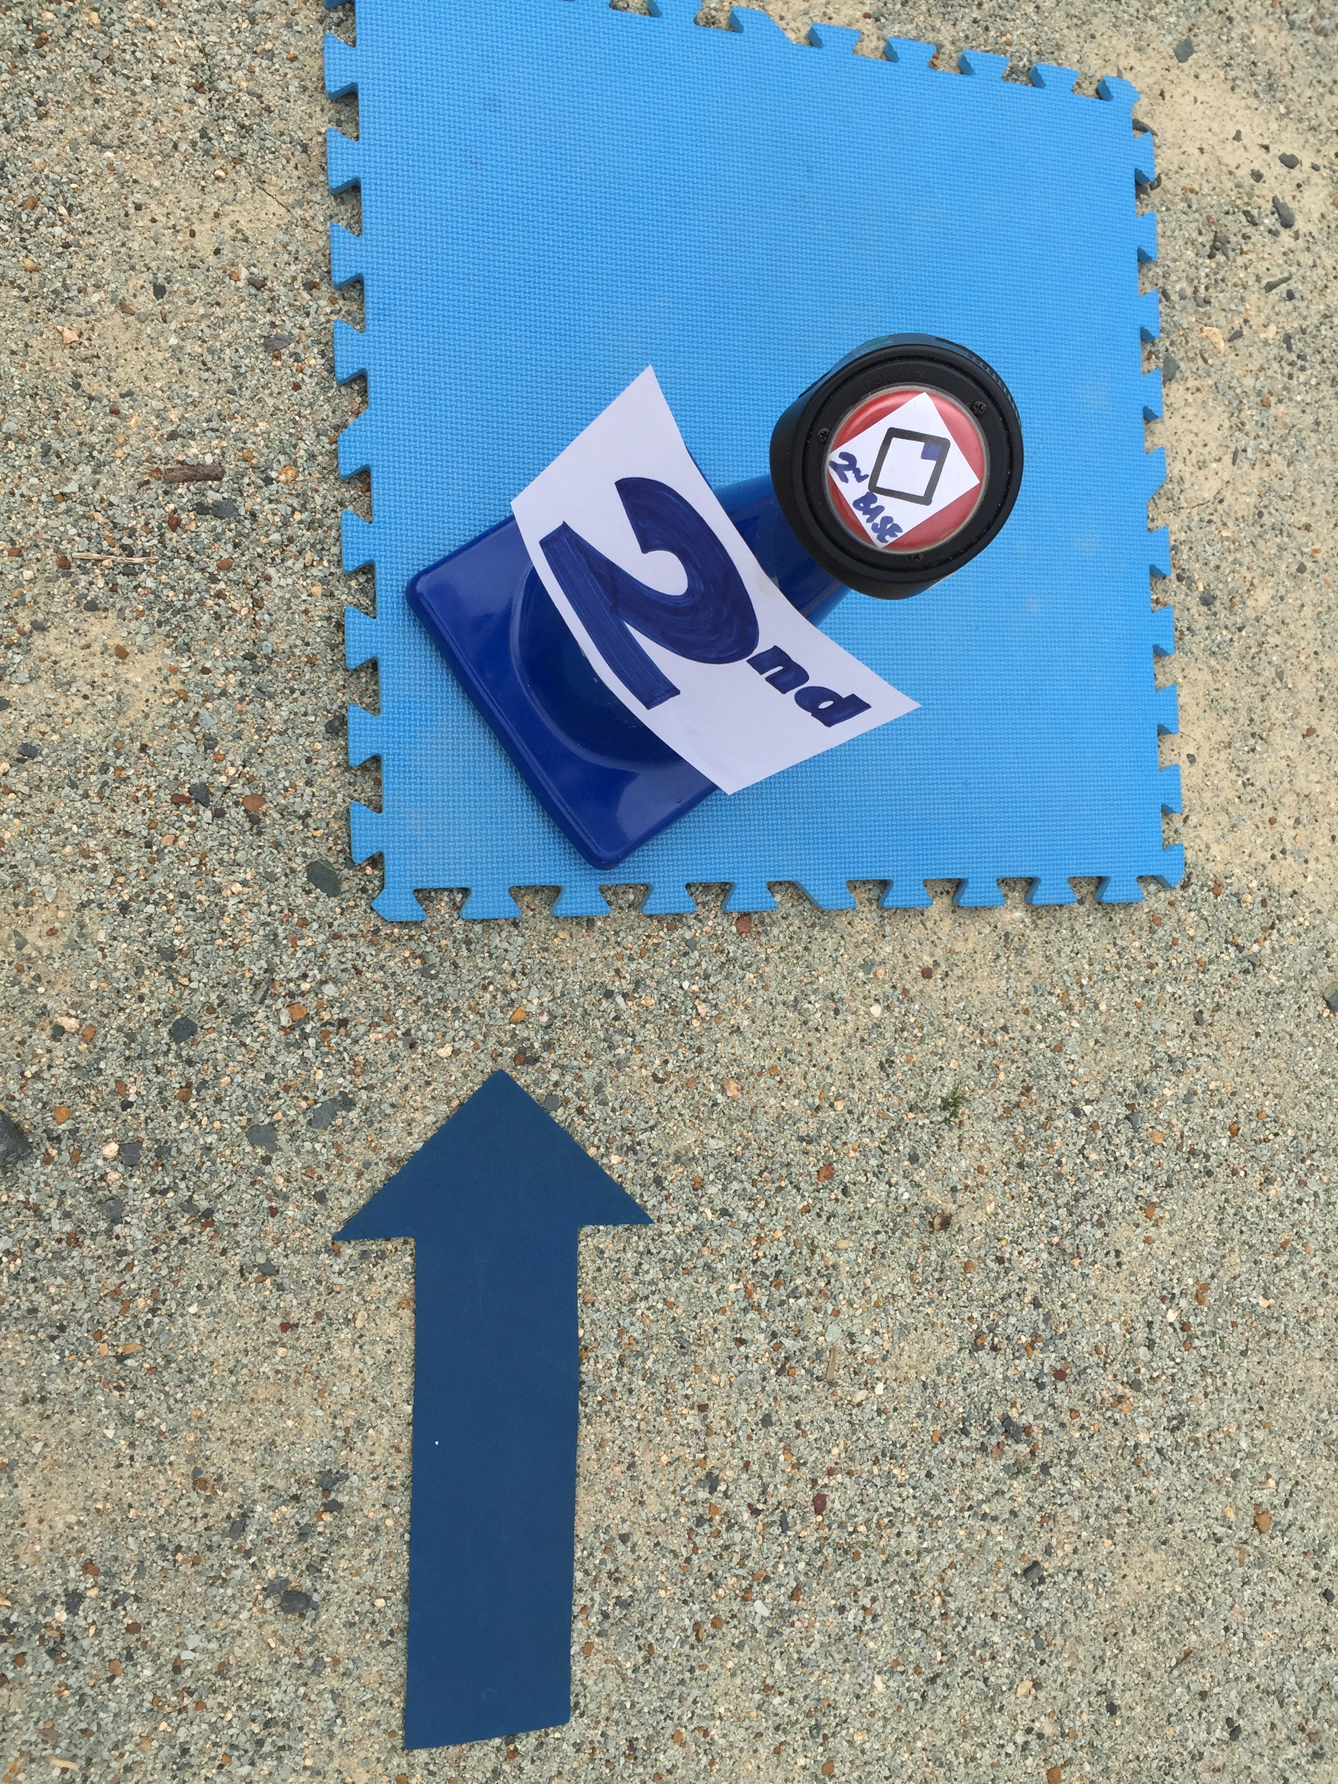
  - Cones: Just add color – many students may not understand game specific vocabulary, but know their primary colors and numbers up to five allowing them to be successful base runners.
    - 1st Base: red cone, labeled “1st” or “1” in red marker, 2nd Base: blue cone, labeled with “2nd” or “2” in blue marker, etc.
    - Replace “Run to first base!” with “Run to red!” or “Run to 1!”
    - Velcro an augmentative communication device, more commonly known as a “switch”, to the top of the cone, and record the name of each base.
      - At each base, students with disabilities can press to activate the switch and listen to the name of the base they are on.
  - Increase Size of Base:
    - Use large mats or carpet squares as the actual “bag” and place cones on top,
    - A larger surface area to “tag” increases accessibility for all students, including students that use wheelchairs and students with visual impairments.
    - Use a mat that’s the same color as the cone, if possible.
  - Direction:
    - Use arrows to direct students from home to 1st, 1st to 2nd, etc.
    - Depending on your playing surface you can draw them in the dirt, draw with sidewalk chalk, or use arrow shaped floor markers or polyspots.

- Playing the Field
  - Place polyspots or other floor markers where you want players to stand while on defense:
    - Prevents the ever-present huddle of students in center field
    - Increases safety
    - Provides a home base for students that have difficulty remaining in personal space or adhering to boundaries.
  - Use a bowling ramp to pitch:
    - Allows students with limited mobility the opportunity to pitch
    - Pitches are consistent and accurate
    - Game Variation – players are allowed to run bases until a player retrieves the kicked ball, sprints to the pitcher, and places the ball back on the ramp. This is a great modification for players who are unable to catch, and a perfect way to increase fitness levels!

Safety Considerations

A few tips and reminders when taking students outside for class:
- Take a walkie-talkie or another reliable form of communication.
- Double check student files for listed allergies, and treatment plan.
- If a student is prescribed an EpiPen, don’t forget the EpiPen!
- Be mindful of uncomfortably high or low temperatures.
- Limit the amount of exposure to direct sunlight. A hat may be needed.
- Allow frequent water breaks or rest breaks.
- Explore areas beforehand to ensure proper accessibility.

