www.nc-ape.com

Dr. Kaky McPeak, CAPE
Wake County Public Schools, NC
kmcpeak@wcpss.net

SCOOTER BALL
(Inclusion game, lead-up to kickball, baseball, softball)

Set-up:
Teacher divides students into teams of equal skill level.
General education students are instructed that the desired outcome is increased participation and movement by students with disabilities (SWD), not competition.
If you have the space: set up multiple games

Equipment:
Scooters: if possible all one color for the fielders and another color for the batters
all general education students sit on a scooter
Pinneys: for one team to further clarify who is on what team
Ball: Omniken ball, therapy ball, small cage ball or the like. No regulation balls, they are
too hard and travel too fast.
Hula Hoops: one for each base
Tall cones: to be placed inside the hula hoops and marked with a number

How to play:
Batting: All participants get a turn before switching to fielding
Alternating batting order: general ed. student, SWD, general ed., SWD, etc.
SWD can put the ball into play by kicking, rolling, tossing, pushing, or striking
General ed. students put the ball into play while seated on the scooter board
Fielding: if the ball is near a SWD they have to touch the ball first before it goes to 1st base
All fielded balls go to 1st base
First base must have control of the ball and yell “STOP”
Scoring: There are no outs. If the runner doesn’t make it to first base they get a do-over.
No foul balls
No strikes
Runner keeps running from 1st to 2nd to 3rd to home until first base says “STOP”
If the runner is between bases they go back to the previous base.

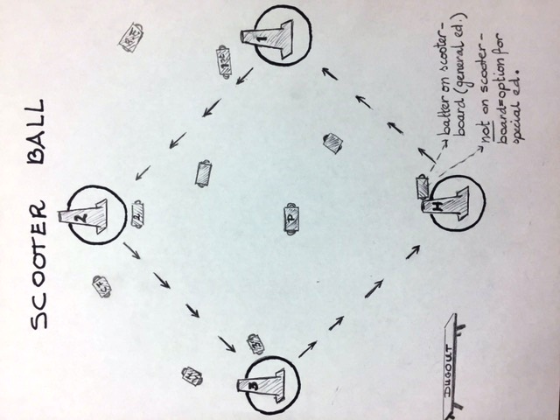

Adaptations/pointers:
- Adults model appropriate inclusion strategies and verbal cues.
  - Run to the ball with a SWD “let’s get the ball”
  - “Let’s pick the ball up”, “Hold onto it”, “Let’s get it to 1st base”
- When SWD uses a wheelchair, place ball in the lap of the student.
  - If needed, place student’s hand on the ball, hold onto both ball and arm, and push student to 1st base.
- Cue a student to field the ball and relay it to another student.
- General ed. students have to stay on their scooter boards.
- Allow the ball to go to any base.
- Modify as you see fit.

Safety tips:
- Only adults push students who use wheelchairs
- Reinforce that increased participation and movement is more important than competition
- Have a “dugout” space to keep those who aren’t at bat safe
- Provide a heads up that any transition is coming up. “Five minutes left in the game”, “last batter is up”, etc.

Good luck and have fun!

