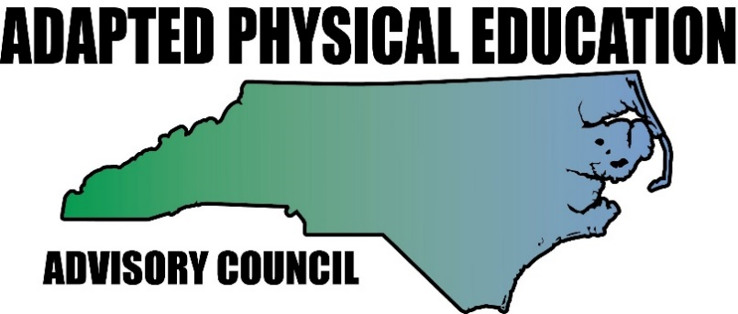www.nc-ape.com

Amy Clark, NC-APE-Advisory Council Contributor
Mecklenburg County, NC
Water Safety Day
This is a great idea for:
- A classroom lesson when you are not able to access your gym.
- All students.
- Incorporating lifetime safety awareness and skills.
This is an important topic that often gets overlooked.
Here are some ideas for activities you can do with a resource list to pull from.
- Create a pool/ocean/lake by taping off an area on the floor.
- Have items or pictures of items commonly found in and around a pool/ocean/lake.
- Invite a lifeguard from a local pool or facility to your school. The lifeguard is the boss at the pool. Everyone has to listed to the lifeguard.
- Create scenes where the students need to identify “safe” and unsafe” conditions.
  - Walking vs running
  - Plastic cup vs glass bottle
  - Rough play (touching others) vs appropriate play
  - Swimming alone vs with a buddy
  - Lifeguard on duty vs off duty
  - Being in a boat with lifejacket vs without lifejacket
  - Feet first entry vs head first entry (depth of the water)
- Talk about ways to be safe around a body of water and follow up with a worksheet of matching pictures.
  - Look before you leap
  - Don’t pack it wear your jacket
  - Be cool follow the rules
  - Think so you don’t sink
  - Reach or throw don’t go
- Borrow equipment from your local pool like lifejackets to have the students practice putting them on and feeling it, then talk about when you need to wear them.
- Use items in your room or borrow some from your local pool to practice reaching assists to help a friend in distress. Emphasize to NEVER go in the water to help someone. That is the job of a lifeguard. Know where to go to get help, and know 911.
  - What floats and what sinks
- Just like in school, discuss and practice the importance of following the rules around water.
Examples of equipment and pictures that can be used:

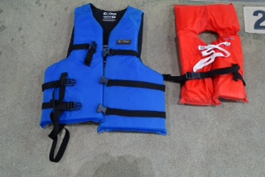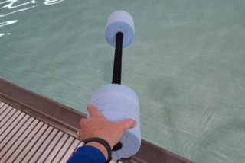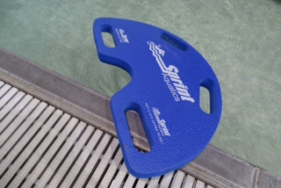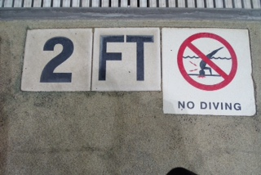

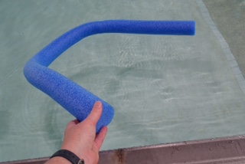

Resources:
- http://www.redcross.org/take-a-class/program-highlights/swimming/whale-tales/resources
- http://www.poolsafely.gov/
- http://classroom.kidshealth.org/prekto2/personal/safety/water_safety.pdf
- http://watersafety.usace.army.mil/

