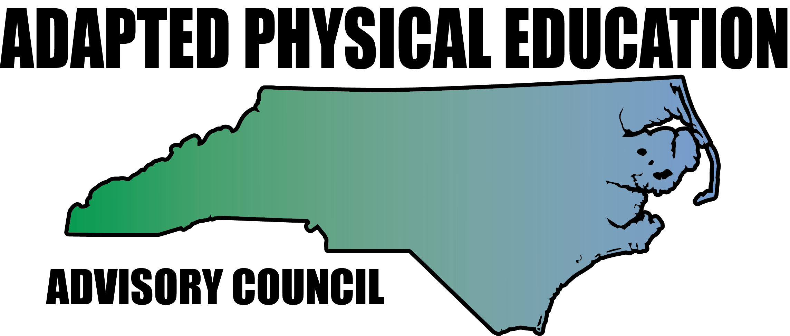

Continuum of Adapted Physical Education Services/Placement/LRE

Adapted physical education (APE) is special education (specially designed instruction) for the Healthful Living/Physical Education (PE) curriculum. All students should receive at least the same amount of physical education regardless of whether they receive general or special education. Just because a student has a disability or is receiving special education does not necessarily mean he/she requires specially designed instruction in physical education or adapted physical education (APE). Using data from student performance, IEP teams determine if the student needs specially designed instruction (Adapted Physical Education or APE) just as they determine the need for any other specially designed instruction. The ultimate goal of the APE program in any LEA is to enable students with disabilities to participate in athletics, physical and leisure activities in his or her community.

Information from this evaluation also provides IEP teams with data regarding student strengths and needs to decide if the student can receive PE education with peers without disabilities or if their needs require that they must be removed from his/her peers without disabilities in order to participate and learn. These decisions must be based on data and must be individualized in regards to student need, not logistical convenience. Each student must receive his/her physical education in an environment that is least restrictive while meeting his/her educational needs and affording participation. APE, like all special education services must be provided on a continuum.

LRE placement options:
- Full independent participation in General Physical Education (GPE)
- Full independent participation in GPE with younger students (nor more than 2 years below)
- Independent participation in GPR in some units of instruction
- Independent participation in some phases of the GPE class
- Participation in GPE with specific APE instruction
- Separate, but equal, APE with peers without disabilities (reverse mainstreaming)
- Separate, but equal, APE with peers with disabilities
- Adapted Physical Education in home, hospital or institution

Support personnel variables that can affect instruction in the LRE:
- Student requires no support
- GPE has APE consultant
- Same age peer buddy
- Older peer buddy
- Older student as teacher assistant
- Adult volunteer as teacher assistant
- Paraprofessional provides support
- APE teacher provides support in general PE program
- APE specialist as teacher

(Auxter, Pyfer, Zittel & Roth. Principles and Methods of Adapted Physical Education and Recreation, 11th edition)

North Carolina Adapted Physical Education Advisory Council (NC-APE-AC)
www.NC-APE.com
NCAPEAC@gmail.com

